**PIZZA SALES SQL QUERIES**

**A. KPI’s**

**1. Total Revenue:**

SELECT

SUM(total_price) as Total_Revenue

FROM

pizza_sales

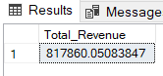

**2. Average Order Value**

SELECT

SUM(total_price) / COUNT (DISTINCT order_id) as Avg_Order_Value

FROM

pizza_sales

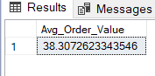

**3. Total Pizzas Sold**

SELECT

SUM(quantity) as Total_Pizza_Sold

FROM

pizza_sales

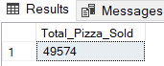

**4. Total Orders**

SELECT

Count(DISTINCT order_id) As Total_Orders

FROM

pizza_sales

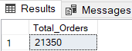

**5. Average Pizzas Per Order**

SELECT

CAST(CAST(SUM (quantity) AS DECIMAL (10,2)) / CAST(Count(DISTINCT order_id) AS DECIMAL (10,2)) AS DECIMAL (10,2)) As Avg_Pizza_by_Order

FROM

pizza_sales

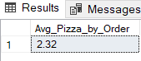

**B. Daily Trend for Total Orders**

SELECT

DATENAME(DW, order_date) as Order_day,

COUNT(DISTINCT order_date) as Total_Orders

FROM

pizza_sales

GROUP BY

DATENAME(DW, order_date)

***Output:***

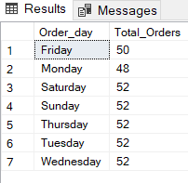

**C. Hourly Trend for Orders**

SELECT

DATEPART(HOUR, order_time) AS Order_hours,

COUNT(DISTINCT order_date) as Total_Orders

FROM

pizza_sales

GROUP BY

DATEPART(HOUR, order_time)

ORDER BY

DATEPART(HOUR, order_time)

***Output***

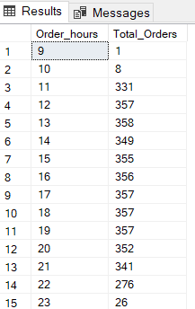

**D. % of Sales by Pizza Category**

SELECT

pizza_category,

CAST(SUM(total_price) AS DECIMAL (10,2)) AS Total_Sales,

CAST(SUM(total_price) * 100 / (SELECT SUM(total_price) from pizza_sales) AS DECIMAL (10,2)) AS PCT_Sales

FROM

pizza_sales

GROUP BY

pizza_category

ORDER BY

PCT_Sales DESC

***Output***

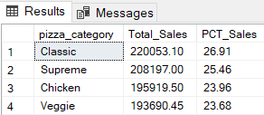

**E. % of Sales by Pizza Size**

SELECT

pizza_size,

CAST(SUM(total_price) AS DECIMAL(10,2)) AS Total_sales,

CAST(SUM(total_price) * 100 / (SELECT SUM(total_price) from pizza_sales) AS DECIMAL(10,2)) AS PCT_Sales

FROM

pizza_sales

GROUP BY

pizza_size

ORDER BY

PCT_Sales DESC

***Output***

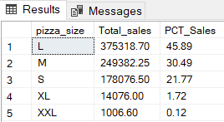

**F. Total Pizzas Sold by Pizza Category**

SELECT

pizza_category,

SUM(quantity) AS Total_pizza_sold

FROM

pizza_sales

GROUP BY

pizza_category

ORDER BY

Total_pizza_sold DESC

***Output***

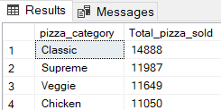

**G. Top 5 Best Sellers by Total Pizzas Sold**

SELECT

TOP 5

pizza_name,

SUM(quantity) AS Total_pizza_sold

FROM

pizza_sales

GROUP BY

pizza_name

ORDER BY

Total_pizza_sold DESC

***Output***

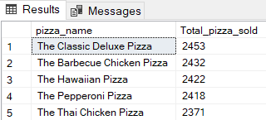

**H. Bottom 5 Best Sellers by Total Pizzas Sold**

SELECT

TOP 5

pizza_name,

SUM(quantity) AS Total_pizza_sold

FROM

pizza_sales

GROUP BY

pizza_name

ORDER BY

Total_pizza_sold

***Output***

